History Rationale
Hanging Heaton CE (VC) Junior & Infant School
Intent
At Hanging Heaton CE (VC) J&I School, our History curriculum is designed to inspire pupils to become curious, reflective and analytical thinkers with a broad understanding of the past. Through carefully sequenced learning experiences, children develop the confidence to question and investigate evidence, explore different perspectives and build informed interpretations of historical events, people and societies. We aim for children to think like historians.
Our curriculum provides a clear structure and sequence of lessons to ensure teachers cover the knowledge, skills and concepts required to meet the aims of the National Curriculum. The intent is to ensure all pupils develop transferable historical skills and concepts which can be applied across all periods of History and equip children for future learning.
At Hanging Heaton, we believe our approach to History helps children to:
- Develop a sense of time, helping them understand how time is measured and recognise that some changes happen quickly while others take place over long periods.
- Work out how and why events happen and understand the consequences of actions and decisions.
- Consider what life was like at different times in the past and develop empathy and understanding.
- Understand that some things can be known with certainty while others remain open to interpretation because History is constructed from the evidence left behind.
- Use evidence to reach balanced conclusions, recognising the importance of checking, cross-referencing and evaluating sources critically.
- Develop curiosity about the past and understand how History shapes identities, cultures and communities over time.
- Become reflective and active citizens who can draw on historical understanding to make sense of the present and contribute thoughtfully to the future.
The curriculum is designed to be both ambitious and accessible, ensuring all pupils can participate, achieve and develop a love of learning in History.

Curriculum Design
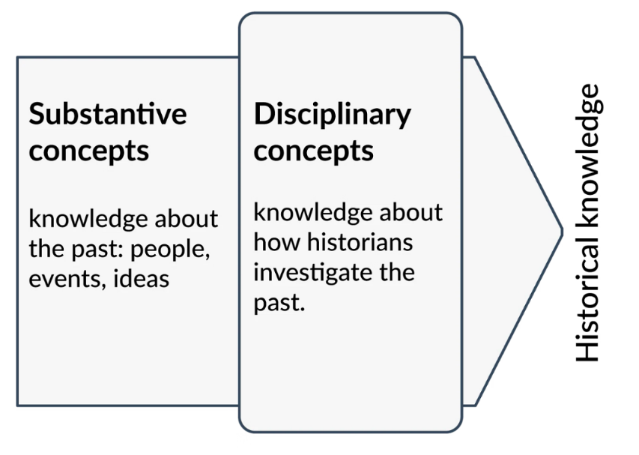
The Five Strands
Based on the aims of the National Curriculum, the following five strands run throughout the History curriculum:
- Topic knowledge
- Chronological awareness
- Substantive (abstract) concepts
- Disciplinary concepts
- Historical enquiry
These strands ensure balanced coverage of both substantive and disciplinary knowledge across all year groups and units.

Types of Historical Knowledge
Following guidance from Ofsted’s History Research Review, pupils develop two forms of historical knowledge:
Substantive Knowledge
Substantive knowledge refers to the established knowledge about the past that pupils gain through studying the History curriculum. This includes knowledge of events, people, societies and the processes of change and continuity that have shaped the world.
Disciplinary Knowledge
Disciplinary knowledge focuses on how historians investigate the past. Pupils learn how evidence is gathered, interpreted and evaluated in order to form conclusions and historical interpretations.

Ways of Knowing
Pupils gain knowledge of History as a discipline by understanding how historical knowledge is created through enquiry, investigation and interpretation. Children learn that historians construct understanding about the past using evidence, sources and interpretation.
Knowing About – Substantive Knowledge
In Key Stage 1, learning is carefully sequenced to develop pupils’ conceptual understanding of the past. Children begin by exploring their own lives and experiences before studying how life has changed over time in familiar contexts. They then move on to learning about historical contexts that may be less familiar.
The National Curriculum states that pupils should “know and understand the history of these islands as a coherent, chronological narrative, from the earliest times to the present day.” Therefore, British History units across Key Stage 2 are taught chronologically to support pupils in understanding this narrative.
For world History, pupils are taught topics within their chronological context. Kapow Primary’s timeline supports teachers and pupils in placing all units within a wider historical framework and making links to prior learning.
Kapow Primary’s History scheme also integrates technology through digital timelines, research tasks and interactive activities. This supports pupils in developing the skills needed to find, evaluate and use historical information effectively.

Spiral Curriculum
Kapow Primary’s History scheme has been designed as a spiral curriculum based on the following principles:
- Cyclical – pupils revisit key knowledge and skills regularly throughout primary school.
- Increasing depth – each revisit involves greater complexity and challenge.
- Prior knowledge – new learning builds upon previous foundations rather than starting again.
This approach ensures children know more, remember more and make meaningful links across periods of History.

Oracy
History lessons encourage discussion, debate and presentation opportunities which enable pupils to articulate their understanding, justify opinions and engage in collaborative learning.
Throughout the curriculum, pupils use oracy to deepen their understanding through questioning, discussion and verbal reasoning. They develop essential communication skills such as:
- Choosing appropriate vocabulary.
- Organising and expressing ideas clearly.
- Listening and responding respectfully to others.
- Explaining and justifying opinions using evidence.

Sustainability and Citizenship
The curriculum promotes awareness of social responsibility and change over time by encouraging pupils to explore significant historical themes such as:
- Human rights
- Conflict and peace
- Inequality
- Migration
- Reform and social change
By understanding how societies responded to major historical challenges, pupils develop a deeper understanding of contemporary issues and informed citizenship.
The curriculum supports pupils in becoming reflective and active members of society who understand how past decisions continue to influence the present and future.

Critical Thinking
Pupils are encouraged to analyse historical evidence, compare perspectives and evaluate the reliability of sources.
This develops their ability to:
- Question assumptions
- Identify bias
- Form reasoned conclusions
- Understand differing interpretations of events
Through enquiry-based learning, pupils become increasingly confident in thinking critically about the past and its impact on the present.

SMSC and British Values
Kapow Primary’s History curriculum supports pupils’ Spiritual, Moral, Social and Cultural (SMSC) development by encouraging them to:
- Explore different perspectives
- Reflect on ethical and moral issues
- Collaborate and communicate with others
- Appreciate cultural diversity
Lessons also promote British values, including:
- Democracy
- The rule of law
- Individual liberty
- Mutual respect
- Tolerance of different faiths and beliefs
This is achieved through activities that encourage respectful debate, discussion and understanding of different societies and viewpoints.
The curriculum broadens pupils’ experiences by introducing them to significant individuals, historical contexts and diverse cultures and traditions.

Continuity of Learning
Kapow Primary’s History scheme aligns with the statutory EYFS framework to ensure continuity and progression from Reception to Year 6.
Key themes and skills introduced in EYFS are revisited and developed further throughout Key Stage 1 and Key Stage 2. The curriculum strands running through the scheme ensure progression in both knowledge and skills.
Subject leaders can clearly identify how learning in Reception forms the foundations for future learning in History.
Building on Early Experiences
Lessons build upon the curiosity, exploration and discussion that are central to learning in EYFS.
As pupils move into Year 1, increasingly structured activities are introduced gradually. Oracy, storytelling and questioning continue to support the transition from informal exploratory learning to more formal subject-based learning.
Development of Key Skills
The History curriculum supports the progressive development of skills introduced in EYFS and strengthened throughout primary school, including:
- Observation
- Reasoning
- Problem-solving
- Questioning
- Communication
Adaptive teaching strategies ensure all learners are supported as they transition towards more formal learning approaches.
Cross-Curricular Links
The History scheme makes meaningful links with other curriculum areas and aligns with EYFS Early Learning Goals.
Connections are made with:
- Communication and language
- Understanding the world
- Expressive arts and design
These links help create a seamless transition into Key Stage 1 and promote pupils’ confidence, independence and engagement.

Inclusion and Diversity
Kapow Primary’s History scheme reflects a broad range of voices, experiences and perspectives.
Representation and inclusion are embedded through:
- Enquiry questions
- Source selection
- Case studies
- Classroom discussion
- The study of significant individuals from diverse backgrounds
Where appropriate, pupils explore the legacy of colonialism and its impact on historical events and narratives.
The curriculum challenges stereotypes and outdated ideologies while helping pupils appreciate the complexity of people’s lives, the diversity of societies and the evolving relationships between groups across time.
Sensitive questions and discussions are carefully planned to support pupils’ lived experiences and backgrounds.

Implementation
Curriculum Structure
Kapow Primary’s History curriculum is designed to be taught for one hour each week, alternating with Geography every half-term. This structure ensures full coverage of the National Curriculum while allowing pupils to develop secure knowledge and understanding over time.

Content and Sequence
In order for children to know more and remember more in each area of History studied, lessons are carefully sequenced and structured to build progressively on prior learning.
At the beginning of each unit, children complete a KWL grid to identify what they already know, what they want to know and, later, what they have learned. Prior learning is revisited regularly and opportunities for retrieval practice are built into lessons to support long-term memory and deepen understanding.
History-related work is organised around key enquiry questions outlined within medium-term plans. These enquiry questions drive learning and encourage children to think critically, ask questions and investigate evidence.
Key vocabulary is explicitly taught and revisited within lessons to strengthen children’s understanding and use of historical language. Knowledge organisers support pupils by outlining the key knowledge and vocabulary expected within each unit.
Teachers are supported through clearly sequenced planning, progression documents and high-quality resources that strengthen subject knowledge and confidence in delivering engaging and well-informed History lessons.

Recap and Recall
Each lesson begins with a short activity revisiting prior learning. These activities help to:
- Reinforce key knowledge
- Activate long-term memory
- Strengthen links between previous and new learning
- Support retrieval practice
Recap and recall activities are varied and engaging to maintain pupils’ interest while embedding important knowledge.

Attention Grabber
Lessons include a short, engaging activity designed to capture pupils’ interest and introduce new learning.
This may include:
- Thought-provoking questions
- Quick investigations
- Images or artefacts
- Interactive discussion
These activities spark curiosity and enthusiasm for the topic.

Main Event
The main part of the lesson focuses on developing understanding of the learning objective through a range of carefully planned activities.
Lessons include:
- Teacher modelling
- Guided practice
- Independent tasks
- Collaborative learning opportunities
- Enquiry and discussion
Activities are designed to support all learners while providing challenge and opportunities for deeper thinking.

Wrapping Up
Each lesson concludes with a reflective activity to consolidate learning.
This may involve:
- Reviewing success criteria
- Discussing key learning
- Applying knowledge in a different context
- Reflecting on enquiry questions
These activities help teachers assess understanding while encouraging pupils to think deeply about their learning.

Adaptive Teaching and SEND
The Kapow Primary History scheme is designed to be fully adaptable for pupils with SEND.
Every lesson includes adaptive teaching guidance which provides strategies for modifying activities and supporting all learners.
Children learn in different ways and History lessons include a range of approaches to support and challenge every pupil, including:
- Scaffolding and flexible task design
- Multi-sensory approaches
- Clear instructions and structured tasks
- Collaborative learning opportunities
- Independent learning opportunities
By embedding adaptive teaching throughout the curriculum, all pupils can access and succeed in their learning regardless of their starting points.
The carefully sequenced curriculum also supports pupils with SEND by avoiding sudden increases in complexity and allowing for steady, manageable progression.

Impact
The impact of our History curriculum is seen through pupils’ increasing knowledge, understanding and enthusiasm for the subject.
Children develop secure chronological understanding, improved enquiry skills and the ability to analyse and interpret historical evidence thoughtfully. They become increasingly confident in asking questions, drawing conclusions and communicating their understanding using appropriate historical vocabulary.
Impact is measured through:
- Pupil discussions and questioning
- Retrieval practice and revisiting prior learning
- Outcomes recorded in books and other forms of presentation
- Teacher assessment informed by progression documents
- Formative and summative assessment opportunities
- Pupil voice and verbal responses
Formative Assessment
Kapow Primary History lessons include ongoing assessment opportunities, such as questioning, retrieval practice and interactive activities.
These enable teachers to assess understanding in real time and adapt their teaching accordingly.
Summative Assessment
Each unit provides an Assessment Quiz and Knowledge Catcher, which allow teachers to measure pupils’ understanding at key points.
These tools help gauge how well pupils have retained key knowledge and skills over time.
Written Outcomes
Pupils demonstrate their learning and provide tangible evidence of progress through a variety of activities, including:
- Structured written work
- Annotated diagrams
- Creative responses
- Extended explanations
- Source analysis activities
Pupil Voice
Lessons encourage discussion, reflection and verbal explanations. This allows teachers to capture pupils’ understanding through questioning, class discussions and recorded responses, supporting a broader view of progress beyond written work.
The use of high-quality resources and engaging lessons helps to raise the profile of History across the school. We aim for History to be valued and enjoyed by both teachers and pupils, encouraging children to continue building on their historical knowledge and understanding throughout their education and beyond.
Nearly all children leave Hanging Heaton CE (VC) J&I School having achieved at least the expected standard, with some achieving greater depth within the standard. SEND pupils make at least expected progress towards their individual targets and disadvantaged pupils make progress in line with their peers.
Children leave Hanging Heaton CE (VC) J&I School with:
- A positive attitude towards History
- A secure understanding of key historical knowledge and concepts
- The ability to think critically and evaluate evidence
- Curiosity and enthusiasm about the past
- An understanding of how History shapes the world around them
The end points of our History curriculum are deemed to be at the end of Key Stage 2, where pupils are equipped with the knowledge, skills and understanding needed for future learning in History and beyond.

